Name : Khan Abdur Rahman Roll No : 231814 Batch : A Class : BE CSE-IOT
MLBC ASSIGNMENT No: 1
Subject: Machine Learning and Block Chain (MLBC)
Topic: Module 1,2 & 3.
Q1. What is Machine Learning? Explain the major types of Machine Learning with one simple real-life example for each.
Machine Learning (ML) is a branch of Artificial Intelligence that enables computers to learn patterns from data and make predictions or decisions without being explicitly programmed for every task. The basic idea is to provide data to a machine learning algorithm so that it can identify relationships and use the learned knowledge on new, unseen data.
The major types of Machine Learning are:
1. Supervised Learning:
In supervised learning, the model is trained using labelled data, where both input and the expected output are known. The model learns the relationship between input and output and uses it to predict the output for new data. It is mainly used for classification and regression.
Example: An email system learns from emails labelled as “Spam” or “Not Spam” and automatically classifies new incoming emails.
2. Unsupervised Learning:
In unsupervised learning, the data does not contain predefined output labels. The algorithm discovers hidden patterns, groups, or relationships within the data.
Example: An online shopping website groups customers according to their purchasing behaviour, such as frequent buyers, occasional buyers, and high-value customers.
3. Reinforcement Learning:
In reinforcement learning, an agent learns by interacting with an environment. It receives a reward for correct actions and a penalty for incorrect actions, gradually learning the best strategy.
Example: A robot learns to navigate a room by receiving rewards when it reaches the destination and penalties when it hits an obstacle.
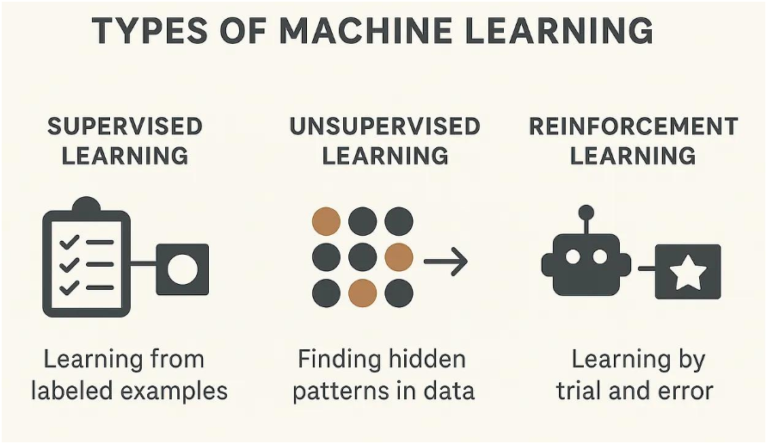
Thus, supervised learning learns from labelled examples, unsupervised learning discovers hidden patterns, and reinforcement learning learns through interaction and feedback.
Q2. What is Feature Selection? Explain why feature selection is important in Machine Learning. Briefly explain Principal Component Analysis (PCA).
Feature Selection is the process of selecting the most relevant and useful features from a dataset while removing irrelevant, redundant, or unnecessary features. A feature represents an input variable used by a machine learning model.
For example, while predicting whether a person has diabetes, features such as Glucose Level, BMI, Age and Blood Pressure may be useful, whereas an irrelevant identification number may provide no useful information.
Feature selection is important because it reduces the dimensionality of data, decreases model training time, reduces noise, improves model performance and makes the model easier to understand. It can also reduce the possibility of overfitting, where a model performs well on training data but poorly on unseen data.
Principal Component Analysis (PCA) is a dimensionality-reduction technique that transforms a large number of correlated features into a smaller number of new variables called Principal Components. These components are combinations of the original features and are arranged so that the first component captures the maximum possible variance in the data, followed by the second component, and so on.
Example: If a dataset contains 20 highly related features, PCA may transform them into 3 or 4 principal components while retaining most of the important information.
Therefore, feature selection chooses important existing features, whereas PCA creates new transformed features called principal components.
Q3. Explain the Decision Tree algorithm with a suitable example. What is the role of Entropy and Information Gain in constructing a Decision Tree?
A Decision Tree is a supervised machine learning algorithm used mainly for classification and regression. It represents decisions in the form of a tree structure. The root node represents the first decision, internal nodes represent conditions, branches represent outcomes of those conditions, and leaf nodes represent the final prediction.
For example, a bank can use a decision tree to decide whether a person should receive a loan based on income and credit score.
Credit Score?
/ \
High Low
| |
Income High? Reject Loan
/ \
Yes No
| |
Approve Reject
The construction of a decision tree involves selecting the feature that provides the best separation of the data. Two important concepts used for this purpose are Entropy and Information Gain.
Entropy measures the amount of impurity or uncertainty in a dataset. If all records belong to the same class, entropy is 0, meaning the data is completely pure. Higher entropy indicates greater uncertainty.
The formula for entropy is:
Entropy(S) = −Σ pᵢ log₂(pᵢ)
where pᵢ represents the probability of a particular class.
Information Gain measures how much uncertainty is reduced after splitting the dataset using a particular feature.
Information Gain = Entropy(parent) − Weighted Entropy(children)
The feature having the highest Information Gain is generally selected as the splitting feature because it produces the purest child nodes.
Thus, Entropy measures the impurity of data, while Information Gain helps the Decision Tree determine which feature should be used for the next decision.
Q4. What is Ensemble Learning? Differentiate between Random Forest and Gradient Boosting with suitable examples.
Ensemble Learning is a machine learning technique in which multiple models, called base learners, are combined to produce a stronger and more accurate model. The main idea is that combining several models can provide better predictions than relying on a single model.
Two popular ensemble learning techniques are Random Forest and Gradient Boosting.
Random Forest is an ensemble of multiple Decision Trees. Each tree is trained using a randomly selected subset of the training data and features. For classification, the final prediction is generally obtained through majority voting, while for regression, predictions can be averaged. Since the trees are built independently, Random Forest can reduce overfitting and provide stable predictions.
Example: A bank can use Random Forest to predict whether a customer is likely to default on a loan by combining the decisions of many different Decision Trees.
Gradient Boosting also combines multiple weak learners, usually Decision Trees, but builds them sequentially. Each new tree focuses on correcting the errors made by the previous trees. The final model combines the contributions of all the trees.
Example: An e-commerce company can use Gradient Boosting to predict customer purchase probability using factors such as browsing history, previous purchases and customer activity.
Random Forest | Gradient Boosting
Builds many trees independently. | Builds trees sequentially.
Uses random samples and feature subsets. | Each new tree focuses on previous errors.
Trees can be trained in parallel. | Trees are dependent on previous trees.
Generally less sensitive to overfitting. | Can achieve high accuracy but requires careful tuning.
Example: Loan default prediction. | Example: Customer purchase prediction.
Therefore, Random Forest mainly reduces variance by combining independent trees, whereas Gradient Boosting improves performance by sequentially correcting errors.
Q5. Explain the basic architecture of an Artificial Neural Network (ANN). Describe the role of weights, bias and activation functions, and briefly explain how backpropagation is used to train a neural network.
An Artificial Neural Network (ANN) is a machine learning model inspired by the working structure of biological neurons. It consists of interconnected processing units called neurons. A basic ANN contains an input layer, one or more hidden layers, and an output layer.
Input Layer Hidden Layer Output Layer
X1 ───────────→ ● ────────┐
X2 ───────────→ ● ────────┼──→ ● Output
X3 ───────────→ ● ────────┘
Weights represent the importance assigned to different inputs. Each input is multiplied by its corresponding weight. A larger weight means that the particular input has a stronger influence on the neuron's output.
Bias is an additional value added to the weighted sum. It allows the neuron to shift the activation function and helps the network learn more flexible relationships.
A neuron first calculates:
z = w₁x₁ + w₂x₂ + ... + wₙxₙ + b
where w represents weights, x represents inputs, and b represents bias.
The value is then passed through an activation function, such as ReLU, Sigmoid or Tanh. Activation functions introduce non-linearity, allowing neural networks to learn complex relationships.
During training, the network produces a prediction and compares it with the actual output using a loss function. Backpropagation then calculates how much each weight and bias contributed to the error by propagating the error backward through the network. The weights and biases are updated using an optimization algorithm such as Gradient Descent.
Input Data → Forward Propagation → Prediction → Loss/Error → Backpropagation → Gradients → Update Weights & Bias → Repeat
Thus, an ANN learns by repeatedly performing forward propagation, calculating the error, propagating the error backward, and updating its weights and biases to produce increasingly accurate predictions.
Random Forest | Gradient Boosting
Builds many trees independently. | Builds trees sequentially.
Uses random samples and feature subsets. | Each new tree focuses on previous errors.
Trees can be trained in parallel. | Trees are dependent on previous trees.
Generally less sensitive to overfitting. | Can achieve high accuracy but requires

